Introduction to AI Assisted Coding Assignment

How to Play Connections - The New York Times Online Game:

Try to find words that match/make sense together.
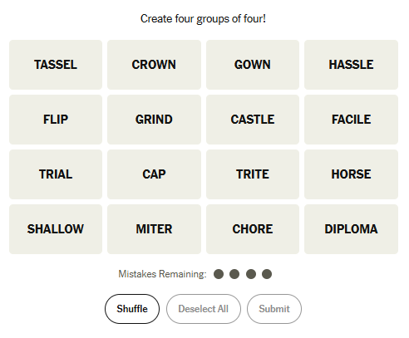

Once you find FOUR words that sound like they belong in a group, select them and click ‘Submit’.
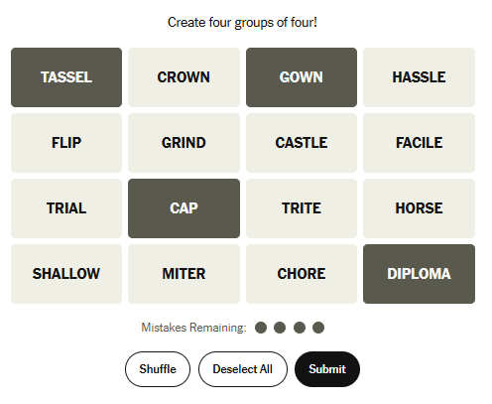
The words “Tassel”, “Gown”, “Cap”, and “Diploma” all belong under the category of “Graduation Gear”.
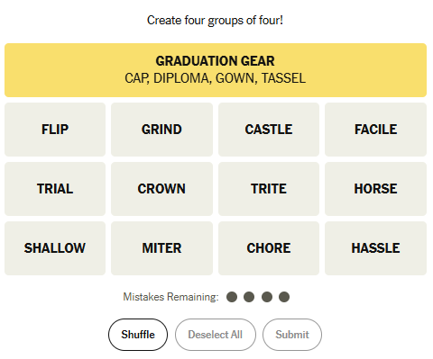

But be careful, you are only allowed 4 mistakes!

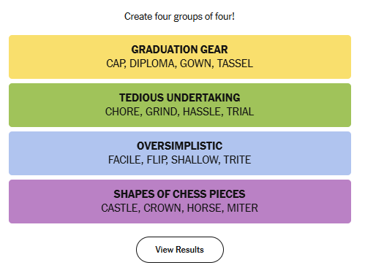
You win by guessing all four categories and having at least ONE mistake remaining.

Assignment:

Now that you know how to play and what an example might look like, it’s your turn to create your own Connections game.

AI Chatbot Options:
You can complete this project using any chatbot that allows you to ask coding-related questions. There are many AI Chatbots to choose from. Here are a few suggestions:

- ChatGPT
- Gemini
- Copilot

You can reference the New York Times version at https://www.nytimes.com/games/connections

Tips:
- Be as descriptive as possible about what you want when prompting the AI engine.
- Plan out what you want to accomplish, and take small steps to reach your end goal.
- Don’t be discouraged if it takes many tries to finalize your project.

Important:
Each AI assistant (ChatGPT, Gemini, Copilot, etc.) may explain or format code differently. Some tools provide full files, while others give short snippets.

If one chatbot gives confusing output, try asking a different one or rephrasing your request.
Always review, test, and debug the code yourself—even AI-generated programs will need adjustments!

Requirements:
You will need these three files to create your website/game: index.html, style.css, and script.js.

Write down the AI Chatbots you used and write a one page paper about the quality of the code the chatbot produced and how much work went into debugging/changing the code.

